SQL PROJECT
1. Objective:
To analyze hospital operational and financial data using SQL and derive actionable insights that improve resource allocation, cost management, patient care, and decision-making.
2. Dataset Description:
Feature | Description
Patients | 150
Departments | Hospital departments
Metrics | Cost, Stay Duration, Vitals
Equipment | Medical devices used
Dates | Admission information
3. Query Categories
Financial Analysis
Queries 1, 4, 8, 12, 18, 20
Patient Analytics
Queries 5, 6, 7, 13
Operational Analytics
Queries 2, 9, 11, 16, 17
Resource Utilization
Queries 3, 14, 19
Executive Dashboard
Query 15

KEY FINDINGS:
1. Department-wise Revenue Analysis: Calculates patient count, total revenue, and average treatment cost by department.
Insight: Identifies the hospital's highest earning departments.
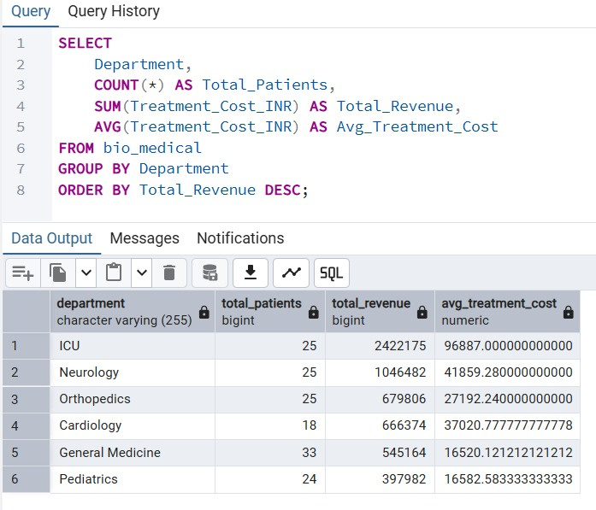
2. Average Length of Stay by Department: Measures average hospitalization days for each department.
Insight: Helps optimize bed occupancy and patient flow.
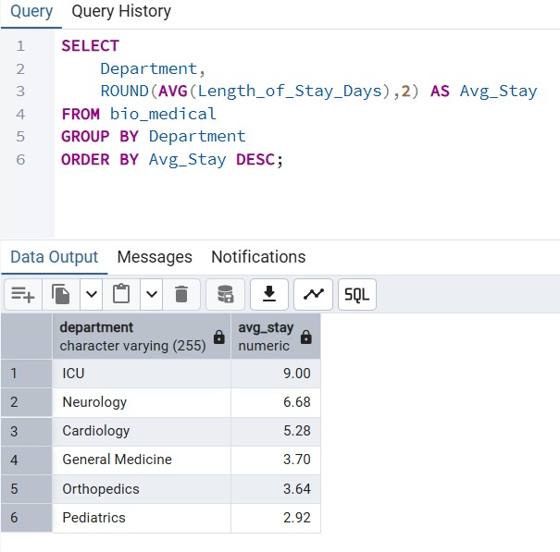
3. Most Frequently Used Equipment: Counts the usage frequency of each equipment type.
Insight: Supports inventory and maintenance planning.
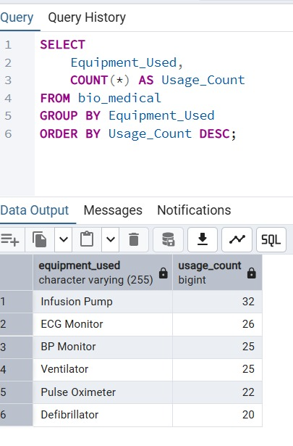
4. Equipment Associated with Highest Costs: Computes average treatment cost associated with each equipment.
Insight: Identifies expensive medical resources.
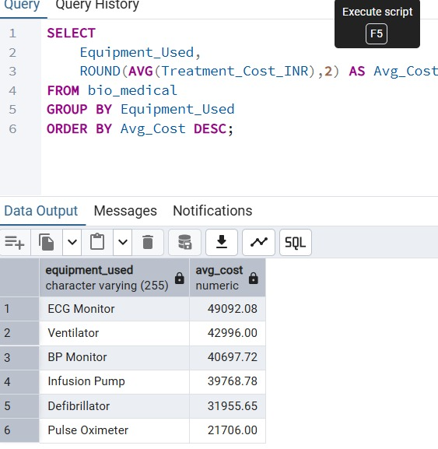
5. Department Handling Critical Patients: Counts patients with oxygen saturation below 90%.
Insight: Shows departments handling the most severe cases.
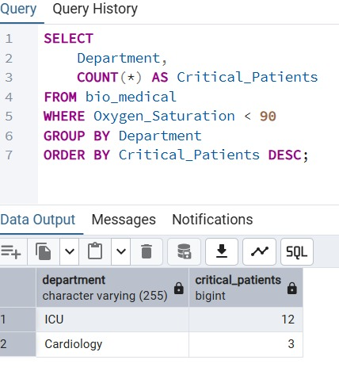
6. Age Group Analysis: Groups patients by age and calculates average treatment costs.
Insight: Reveals spending patterns across demographics.
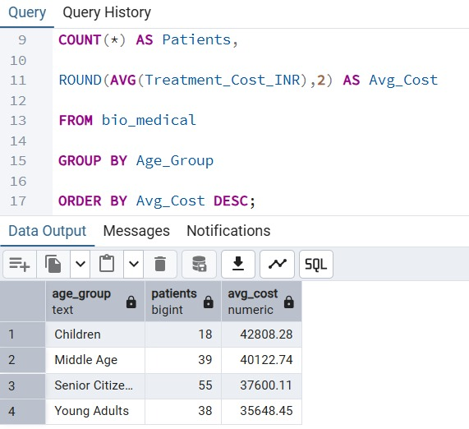
7. Monthly Admissions Trend: Counts patient admissions month-wise.
Insight: Detects seasonal admission trends.
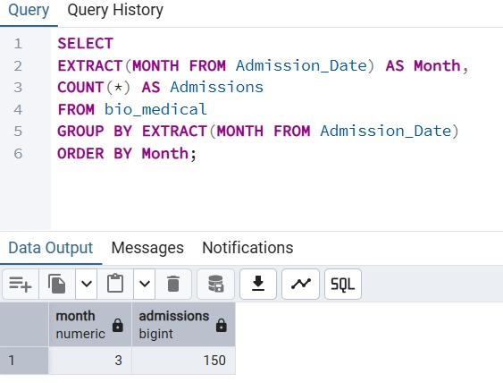
8. Top 10 Most Expensive Patients: Lists patients with the highest treatment expenses.
Insight: Helps identify major cost contributors.
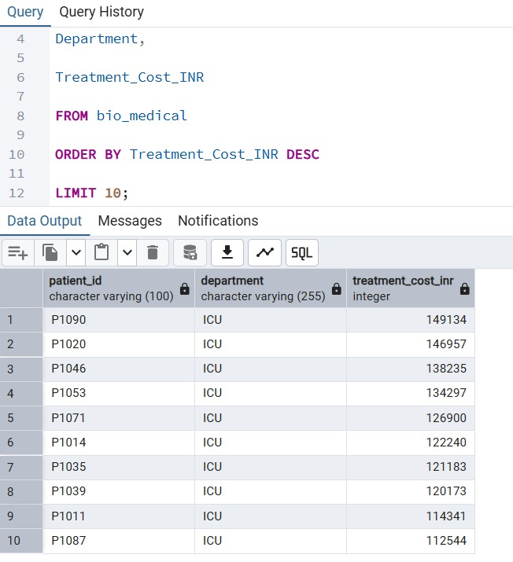
9. Cost per Day Analysis: Calculates treatment cost per hospitalization day.
Insight: Evaluates operational efficiency.
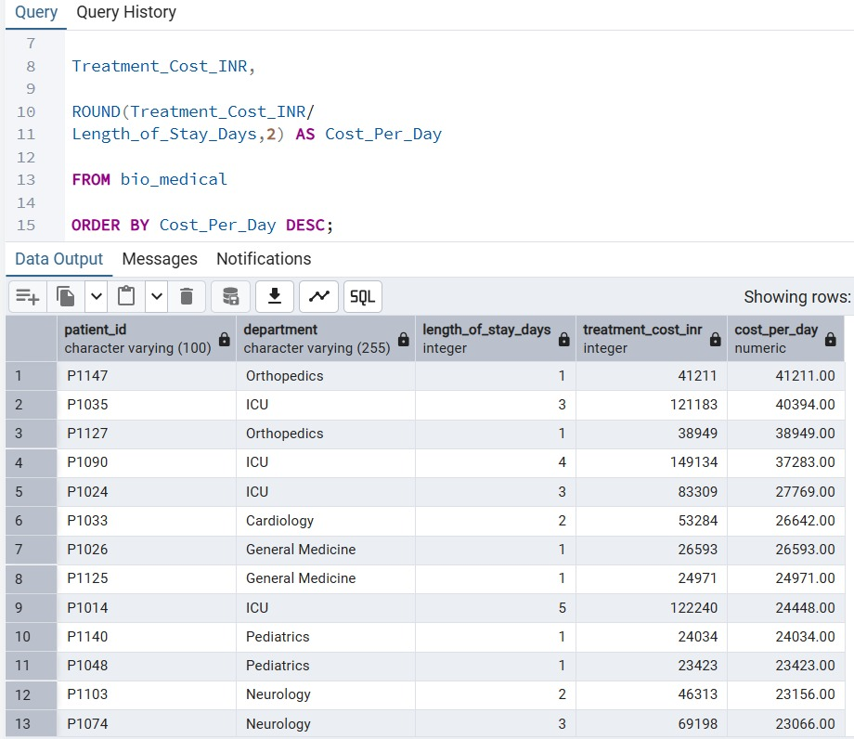
10. Average Vitals by Department: Computes average vital signs by department.
Insight: Indicates patient health profiles across departments.
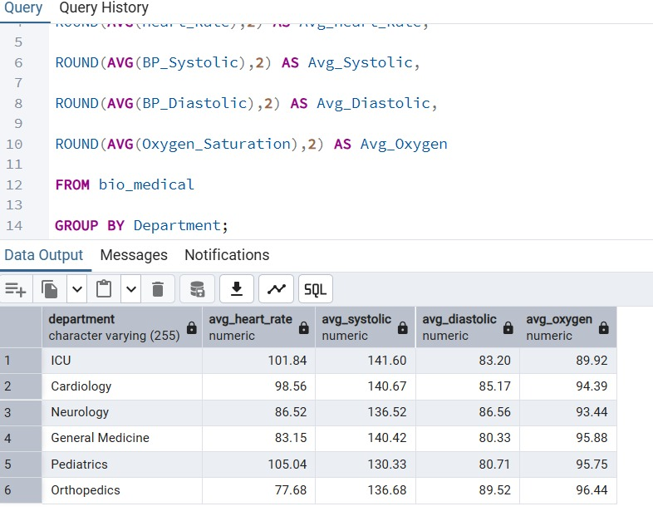
11. Department-wise Bed Utilization: Sums total hospitalization days by department.
Insight: Measures bed occupancy levels.
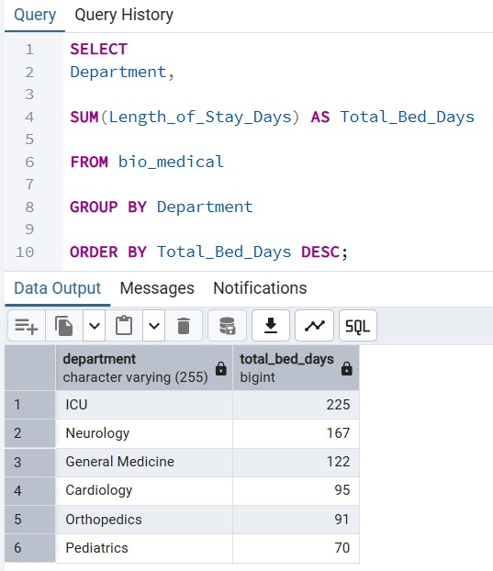
12. High-Cost Patient Segmentation: Counts patients with treatment costs above a threshold.
Insight: Identifies departments with expensive cases.
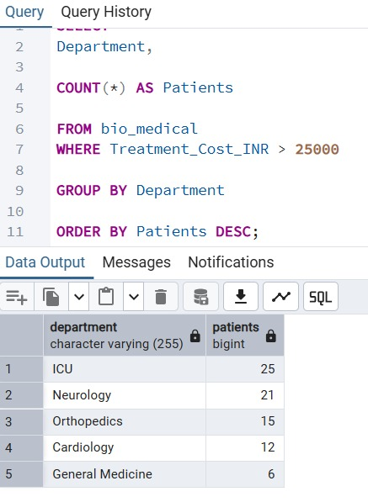
13. Correlation Between Stay Duration and Cost: Relates hospitalization length with treatment cost.
Insight: Shows how longer stays impact expenses.
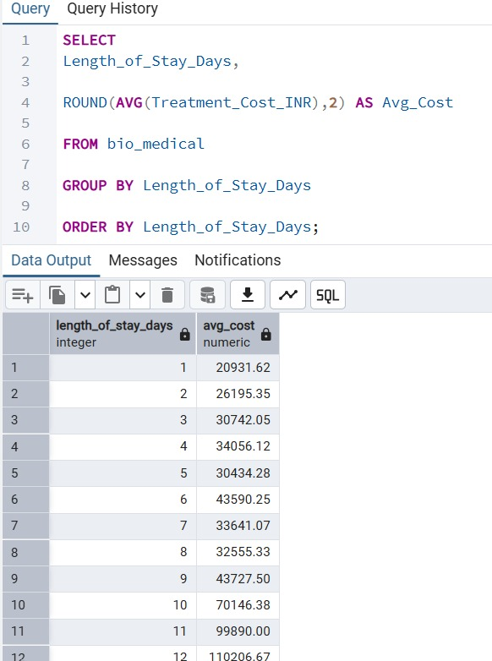
14. Equipment Demand by Department: Measures equipment usage across departments.
Insight: Assists in resource allocation decisions.
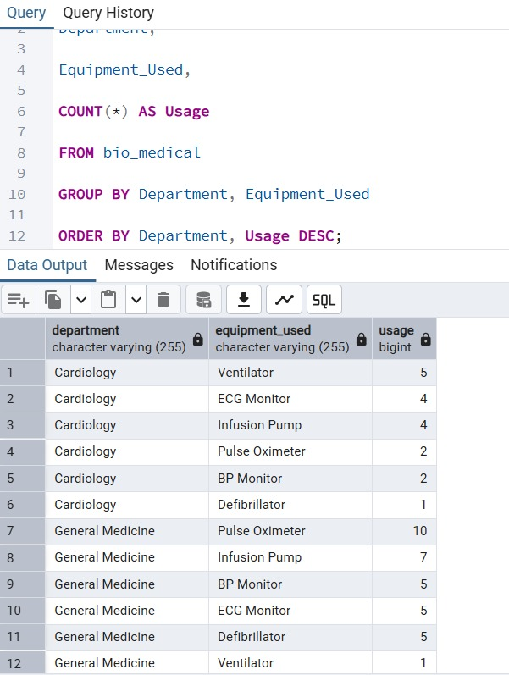
15. Executive KPI Dashboard Query: Summarizes key hospital performance metrics.
Insight: Provides an overall operational snapshot.
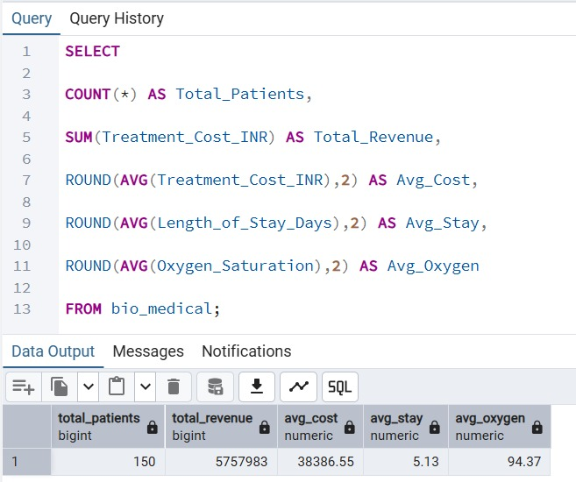
16. Department-wise Patient Load Distribution: Calculates patient share handled by each department.
Insight: Identifies heavily burdened departments.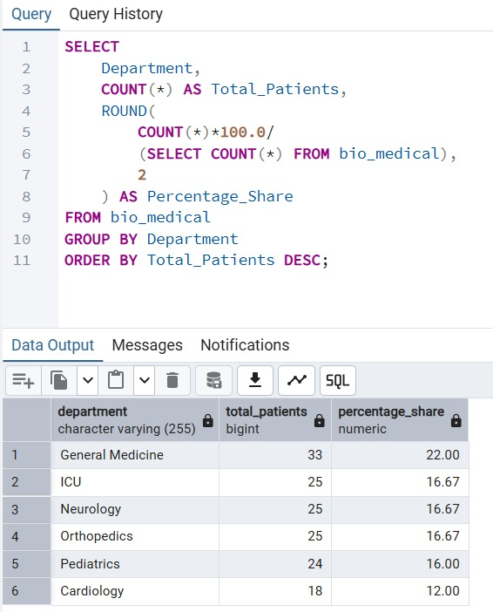
17. Departments with Highest Readiness Burden: Counts patients staying longer than average.
Insight: Helps detect departments with prolonged admissions.
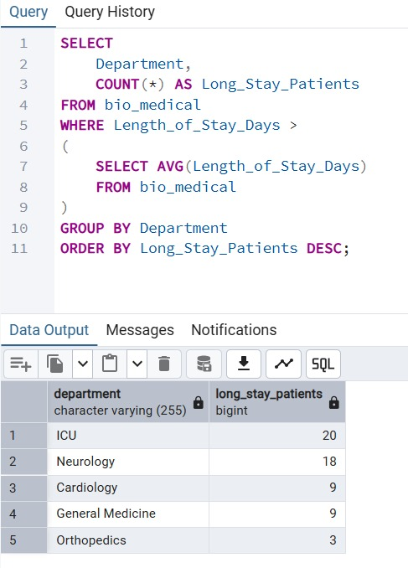
18. Revenue Contribution of Each Equipment Type: Calculates revenue generated by each equipment type.
Insight: Identifies high-value medical assets.
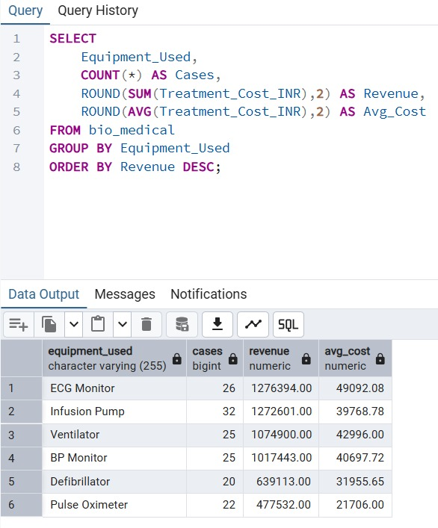
19. High-Risk Patient Analysis: Counts patients with low oxygen and high heart rate.
Insight: Reveals departments treating critical conditions.
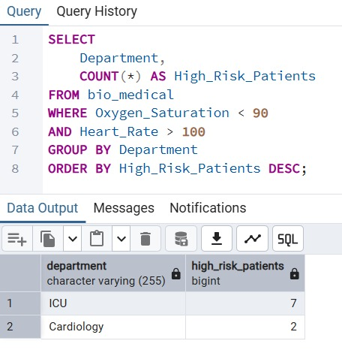
20. Department Efficiency Analysis: Measures revenue earned per hospitalization day.
Insight: Evaluates departmental operational efficiency.
